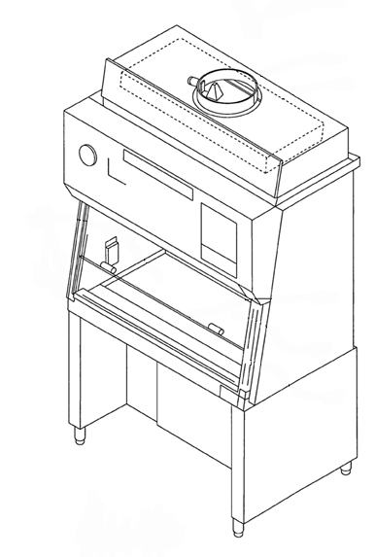
Did you know?
Biosafety Cabinets (BSCs) can consume around 11 to 15kWh per day – about half as much as a home in the US or a full home in Europe.
Ducted vs Unducted
Depending on the type of cabinet you have, it may exhaust air to the outside (ducted) or exhaust air back into the lab (unducted).

Shut Down Completely
If your hood is unducted, turn it off completely when not in use. Before use just turn it on for 5 minutes and wipe with disinfectant.

UV Lights
UV lights are not recommended by the Center for Disease Control (CDC) and the National Institute of Health (NIH).
Closing the Sash
If your hood is ducted, leaving the sash open is like leaving a window open. You should close the sash when not in use to prevent excess conditioned air from being vented to the outside.

Energy Reduction Strategies
Biosafety Cabinets (BSCs) can consume somewhere around 11 to 15kWh per day[1], depending on usage, manufacturer, type and size. If you are using a UV light in your BSC, you could be using an additional 0.5 kWh per day[2]. The average home in the US consumes around 33kWh per day [3] and in Europe the average home consumes about 10kWh per day[4]. So your BSC’s could be consuming somewhere between 1/3 to a full house worth of energy each day! | - Turn off when not in use - If you have an unducted BSC (typically a Class 1, Class 2 Type A1 or A2), or one that is not connected to the laboratory exhaust ducts that expel air into the atmosphere, you can generally shut these down when they are not in use. Please first check with your building administrator to ensure your BSCs are not ducted and part of the laboratory air balance.) To begin using your BSC again, turn it on for 5 minutes and then wipe down surfaces with the appropriate disinfectant [5].  - Close the sash when not working in the cabinet – If you have a ducted BSC (typically Class 2 Type B1 or B2 or Class 3) these operate very much like a chemical fume hood. Filtered air is moved through the cabinet and exhausted to the atmosphere through the building exhaust system. These types of cabinets are typically part of the air balance in the room and cannot be turned off. If the sash is left open when not in use, conditioned air is constantly being pulled from the room and exhausted through the roof. Considerable energy is needed to generate this conditioned air with the correct temperature and humidity for the lab. So leaving the sash open exhausts excess air and increases energy consumption through the air handling system.  - Don’t use UV lights – There is a considerable amount of literature on this topic, but the short of it is, the Center for Disease Control (CDC) and the National Institute of Health (NIH) agree that UV lamps are not recommended nor required in BSCs. There are safety concerns related to the use of the UV light as well as concerns that the UV light is not performing sterilization at the levels assumed by most users. Below we give some recommended reading on this topic, and suggest that you review the literature to determine if you need to use UV light and if so that you are using it correctly. If you can turn it off, it could save you about 100kWh/year, the equivalent of driving a car almost 200 miles (320km)[6].

Recommended Readings on the Use of UV Lights

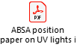 | America Biological Safety Association (ABSA)  Position Paper on the Use of Ultraviolet Lights in Biological Safety Cabinets |  | Use of Ultraviolet Lights in Biological Safety Cabinets: A Contrarian View
 | Primary Containment for Biohazards: Selection, Installation and Use of Biological Safety Cabinets | 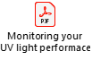 | Monitoring Ultraviolet Lamps in Biological Safety Cabinets with Cultures of Standard Bacterial Strains on TSA Blood Agar
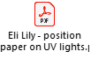 | Position Paper on the Use of Ultraviolet Lights in Biological Safety Cabinets | 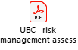 | The University of British Columbia Guidance Document on the Use of UV Germicidal Lamps Inside Biosafety Cabinets

References

[1] https://www.colorado.edu/ecenter/sites/default/files/attached-files/a2_norberg_031615.pdf
[2] Data not published; MGL metering at biopharmaceutical company.
[3] https://www.epa.gov/energy/greenhouse-gases-equivalencies-calculator-calculations-and-references#houseenergy
[4] https://www.ovoenergy.com/guides/energy-guides/how-much-electricity-does-a-home-use.html
[5] Primary Containment for Biohazards: Selection, Installation and Use of Biological Safety Cabinets. U.S. Department of Health and Human Services, 2000.
[6] Derived from https://www.epa.gov/energy/greenhouse-gas-equivalencies-calculator.

