Title:
[Green Labs or your program name] program launches to improve lab sustainability.
Description:
[Org name] launches a partnership with the non-profit My Green Lab to evaluate and improve the environmental impact of our labs.
Copy:
Background paragraph – share compelling statistics regarding impact of labs on the environment, commitment of organization to sustainability from other organization sustainability messaging.
Did you know laboratories generate 12 billion pounds of plastic waste each year? While research facilities do their best to dispose of waste appropriately, our planet is running out of space. We can do better. [Org name] is committed to advancing our research while preserving the health of our planet. To reduce our environmental impact, we are embarking on a journey to receive a sustainable lab certification from the non-profit, My Green Lab- the program will be called [program name] – and we need your help!
The program is sponsored by [sponsor name & title] and will be managed by [team lead name and title].
“We are excited to engage our scientists in applying their innovative minds to advancing not only the scientific areas of research they study, but also to HOW we conduct the research in a more sustainable way,” states [sponsor name].
The certification process will begin with an initial assessment, which will be launched [in which labs] over the next [time period]. Following these assessments, the results will be shared locally, and improvements will be made over a 4-8 month period. After implementing the recommended actions, the assessment will be conducted again to show improvements and the labs will receive their My Green Lab certification and level.
Quote from scientist, “I’m excited to learn more about sustainable lab practices and how we can innovate our science to have less of an impact on the environment as we do our work.”
If you have questions about how to participate, please reach out to your local [program name] team lead. You can also follow #greenlabs on [internal social media channel] for updates.

Site/Lab | [Program name] Team Lead | Survey launch date

My Green Lab (www.mygreenlab.org) is a global not-for-profit organization committed to creating a culture of sustainability through science. In addition to motivating behavioral changes in and around the lab, emphasizing ease and fun of improving with measurable results, they are leading data-driven research into resource consumption to help set quantitative and qualitative standards against which future sustainability efforts will be measured.

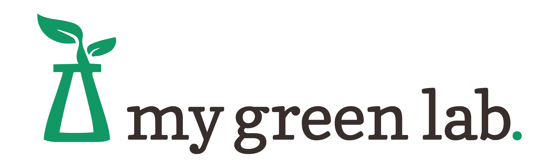
Your org logo

