Shut the Sash Sticker Templates

Looking to start your own ‘Shut the Sash’ campaign? Take a look at this collection of sticker templates that we’ve gathered from a number of wonderful organizations. Consider using these stickers as inspiration for your own sticker or click on the image and download the sticker template from each organization’s website. Shut the Sash stickers are a great way to remind people to close the fume hood sash, which is not only a sustainability best practice but also a safety best practice. Usually, the best stickers are those with a large arrow going from red to green indicating that a closed sash is more safe, and consumes less energy.

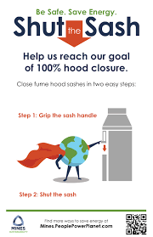 | 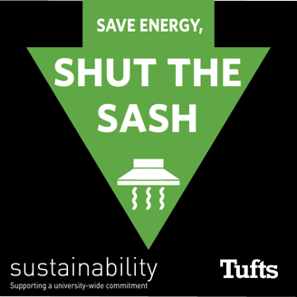
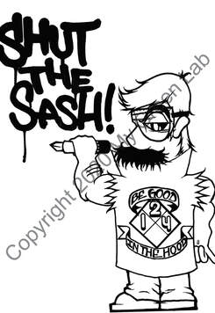 | 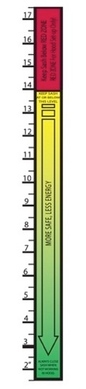  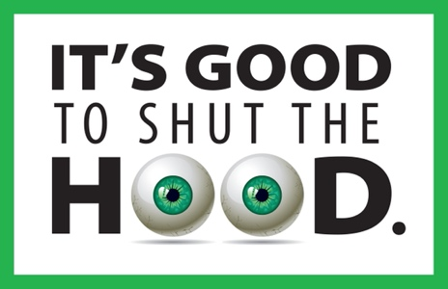
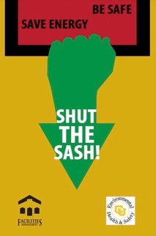 |  | 